Jackson project is used to convert json to java object and vise-versa.

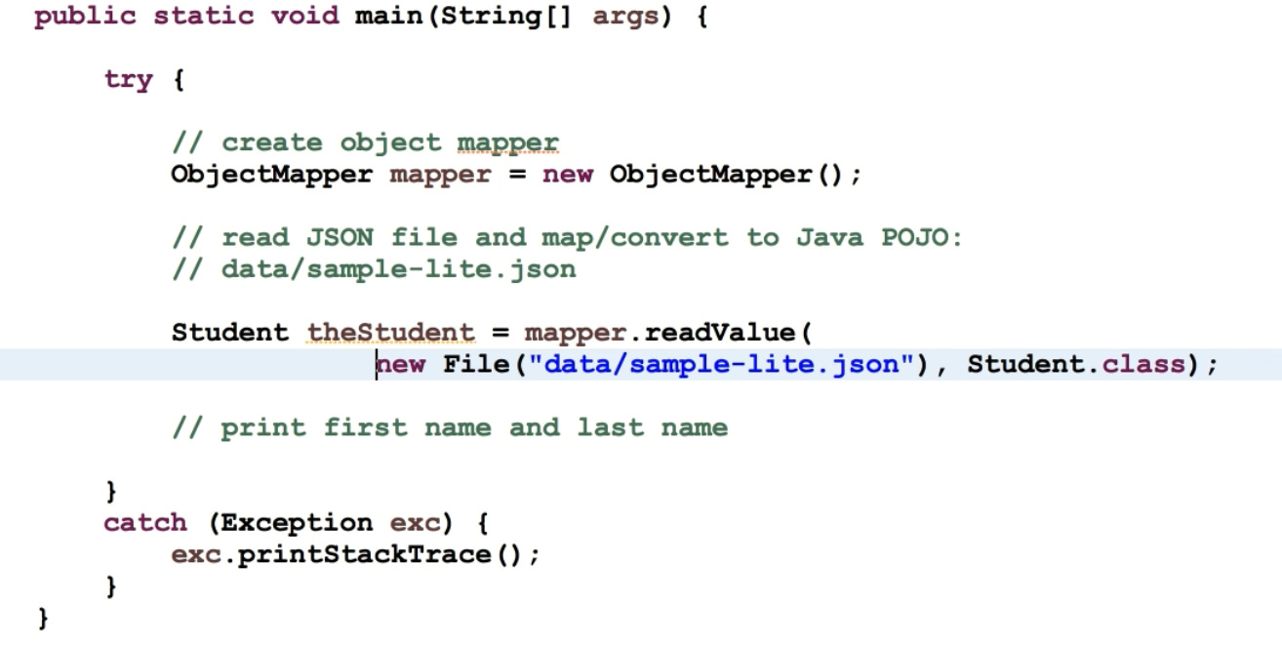

This basically explains everything about reading data from a json file. Of course, we have to create classes that have matching property.

One thing to note here is, Jackson calls the getter and setter of the class. So, we must specify them.

If we want unknown property ignored, we set annotation like this on the class.



